Chess made in MonoGame by Daniel Casey

******** Not For Grading*********

** notes taken during development**

Design of Game

Things game needs

* Playable chess prototype
* Start screen
* 2 player mode
* 1 player mode
* List of moves made
* Mouse drag interface
* Input number interface
* Sounds
* Options screen
* Font selection
* Server Option

# Playable Chess Prototype

TODO

* Make taking piece mechanic
* Make turn base mechanic
* Create list of FullBoards// make each board state what it is holding EG: white pawn, Black Knight;
* Add in special moves rook to king and En passant
* Add logic for board to check if it is empty or if it contains _blackPiece or _whitePiece
* Make list of boards that contain pieces to check if potential moves should stop or not
* Create functions that return potential moves including taking moves.
* Clean up code// the part were we add in pieces
* Make board
* Make chess piece classes
* Create logic for potential moves
* Lock pieces into moving only potential moves
* Sort potential moves to if blocked don’t show after

Logic for checking potential moves

And piece is bishop;

Say piece is in Point(3,1);

Potential moves for bishop is {

Point(3,1) // start Point going up and left

Point(2,2) if point empty add to potential moves else go to start point

Point(1,3) if point empty add to potential moves else go to start point X||Y == 1||8 go to start point

Point(3,1) // Start Point going up and right

Point(4,2)

Point(5,3)

Point(6,4)

Point(7,5)

Point(8,6) X||Y == 1||8 go to start point

Point(3,1) start Point going down and left // X||Y == 1||8 go to start point

Point(3,1) start Point going down and right // X||Y == 1||8 end loop

}

Make list of all boards that contain pieces

9/1/23

Make taking pieces mechanic

Fix highlighted squares //Done

Adding in player turn description

Take it from there!!!!!

Taking mechanic

When a potential moves shows a square to contain an enemy piece it is highlighted red to show that a taking move is available.

^^ current state

VVV what I want to happen.

When new move is on to one of the enemy pieces the enemy piece is moved off board and is no longer able to be selected.

10/01/2023

Fix bugs regarding taking pawns and such…..

Ok so bugs are

Pawns can take pawns

Figured it out……..

Turns out the update lambda function in the SpriteChessBoard class was only taking the first item in the list and that’s all

So its working now woohoo

13/01/2023 morning

//TODO

Set up the check function

Set up check mate

Arrange taken pieces on left if white and right if black

Fix recentre bug and stop pieces being placed off board while in play

For king check function first off

If white has moved then black king runs function IsKingInCheck(chessPiece king) that will return a bool

In the function the king will check all potential attacks

We will take the potential moves of the queen and apply that to the king as well as the potential moves of the knight

This will give the king full range of every potential move

Like when the board detects and enemy if the king detects a rook of the opposite colour where the rook could in its next move

Currently the function to not allow self-check is working

So when the white king is in check the and the offending piece is takeable by white the game still classes it as an illegal move.

This is because the game still thinks the offending piece hasn’t or wont be moved;

Confirms if in check now

Still need to fix bug in taking offending item.

13/01/2023 evening

//TODO

Sort out snap to centre

Organize Dead Pieces

Sorted out snap to centre and added message board into game

Will need to save moves so I can add an undo feature

Found bug with knights. Didn’t register the check

Bug found with potential moves when any piece is released in potential moves they move and timer ticks over

14/01/2023 morning

Fixed listing dead enemies

Fixed bug in taking enemies while in check

Fixed bug in wrong colour pieces being selectable. Solving this problem fixed another

Added feature that selected board turns blue to show what piece is selected

//TODO

Fix bug that pawns cant put kings in check

Going into the isKingInCheck() and setting up for it to check for pawns

Fixed bug that caused is king in check to skip over blocking pieces

Set up Final Phase

CHECKMATE………..

Once Check mate is done then the prototype will be complete and I can focus on polish up the UI

Optional extras would be:

The king to castle

En passant

Checkmate is only available when the king is in check, the king has no moves to remove its self from check, the move cannot be blocked by another piece, and the offending piece cannot be taken without putting the king into check.

Bug found knights not registering check

Kyle found bug

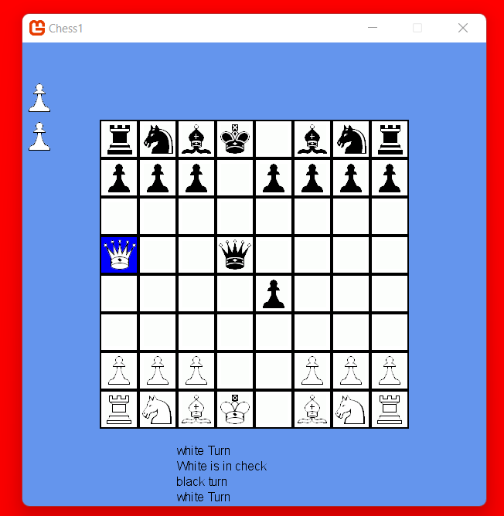

White in check

white turn

white queen cannot take offending queen

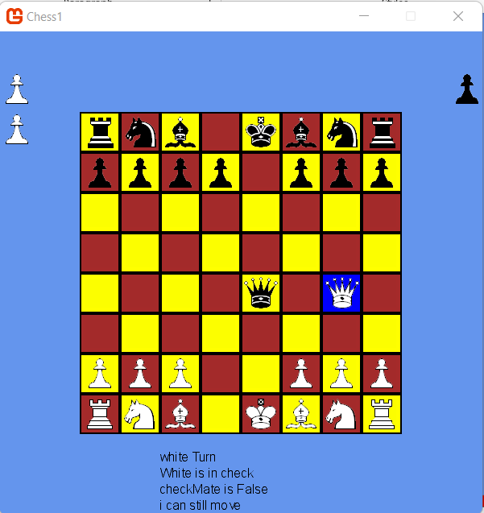

When the white king is in check the offending piece cannot be taken

Dunno why

Will need to do some research

17/01/2023

//TODO

Creating start screen

Welcome sounds

Options screen

18/01/2023

Finalised testing the checkmate function. Tested every scenario I can think of and fixed bugs accordingly. Game is now a fully functioning chess game with a win state.

Added in sound effects and win state.

19/01/2023

Finish UI

Add in button to start Game

Finish message box

Fix position of dead pieces

Setting up MessageBoX!!!!